Prithwi Secondary Boarding School

Final-Term exam

Class: L.K.G F:M=50

Subject: Maths P:M=20

Name: …………………………………………………………………………..

Q.NO.1. What comes after and in between? [14]

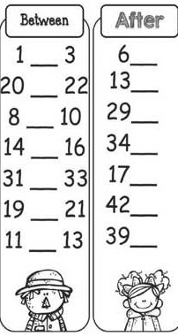

Q.NO.2. Tick the following instructions. [6]

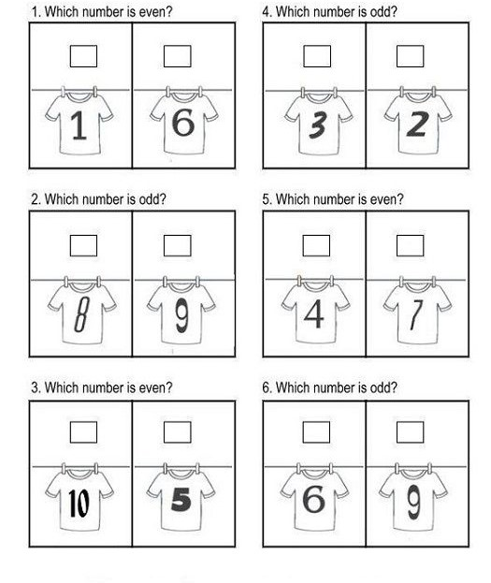

Q.NO.3. Write the missing numbers. [20]

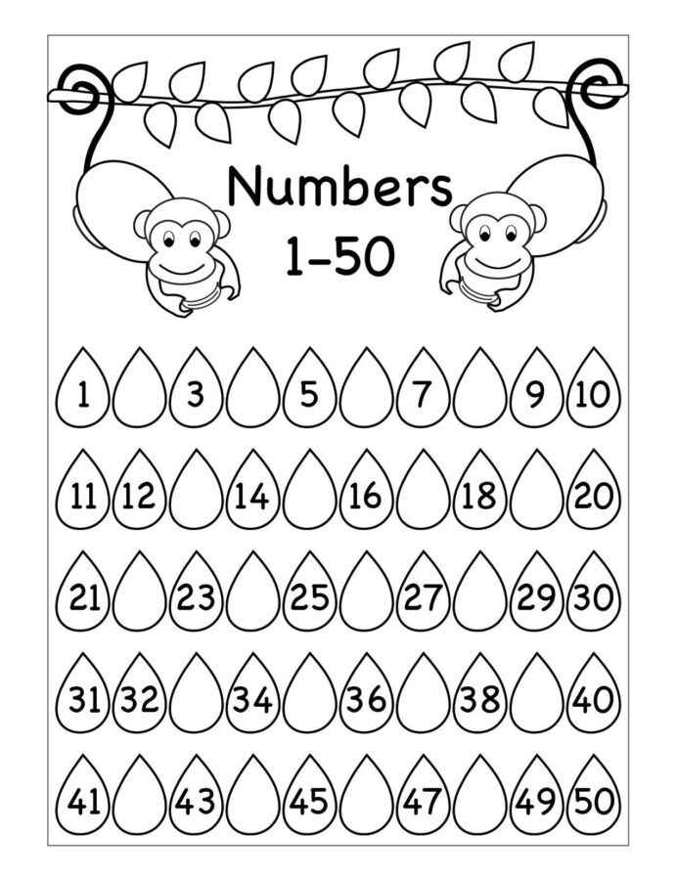

Q.NO.4. Addition. [6]

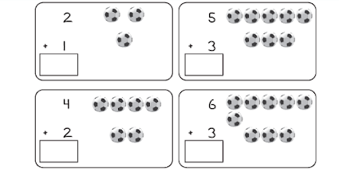

Q.NO.5. Match the numbers with their number name. [4]

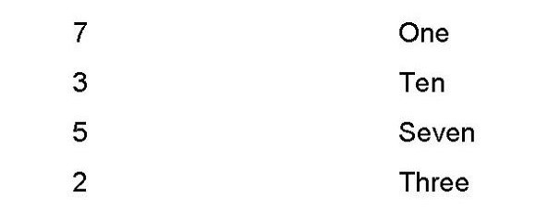

‘Best of luck’